**Install Apache Tomcat in Ubuntu**

Choose & Create the Ubuntu 20.04 instance

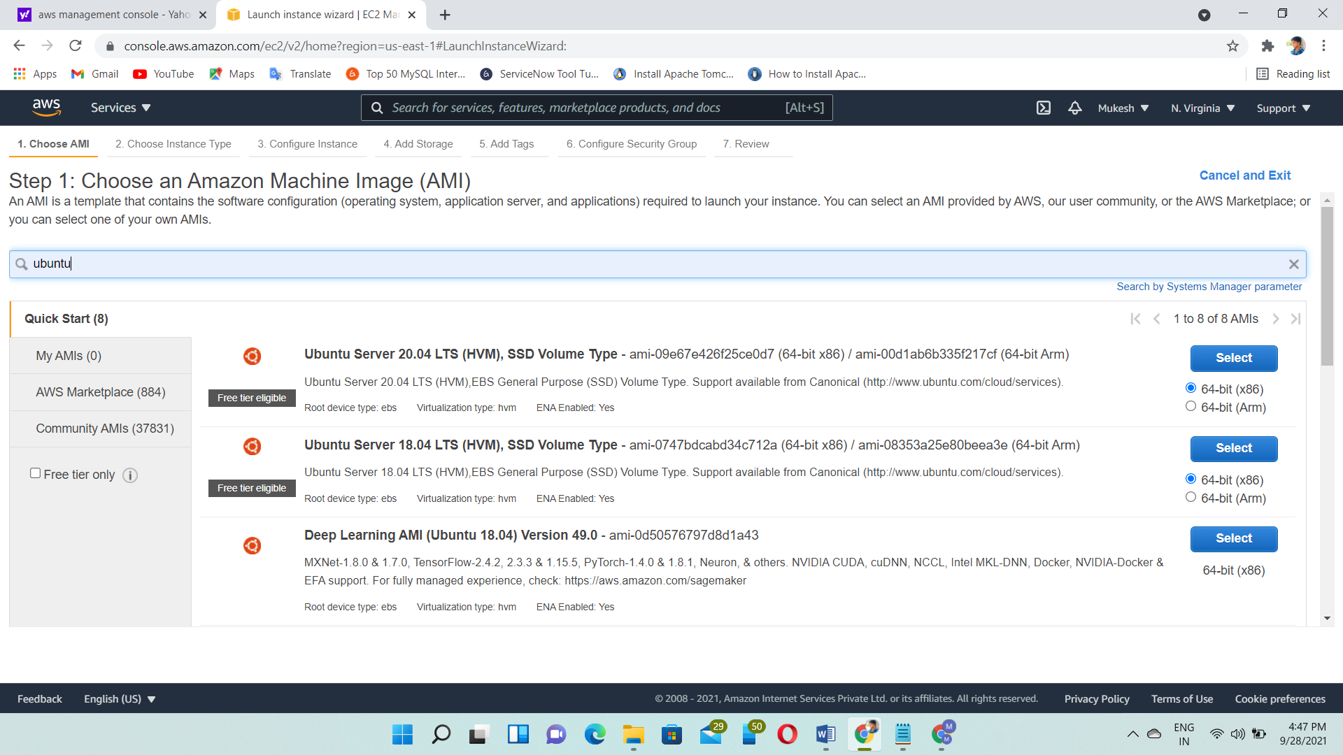

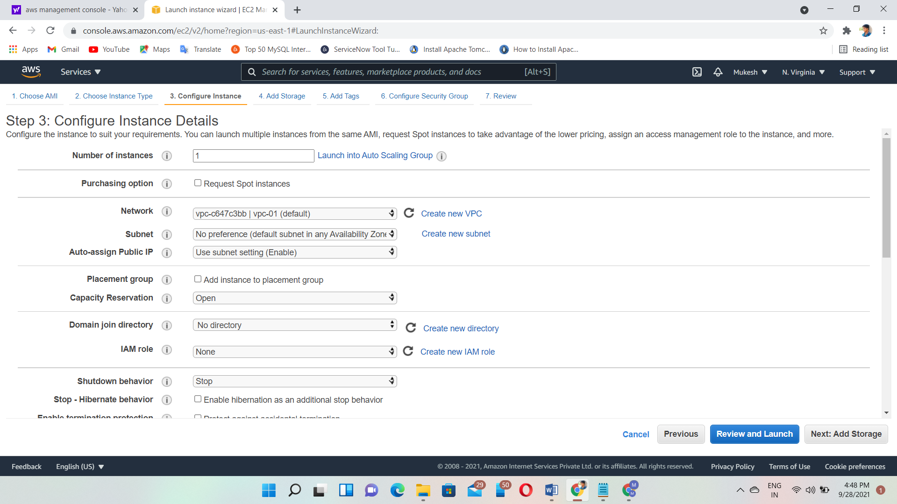

Allow All Traffic

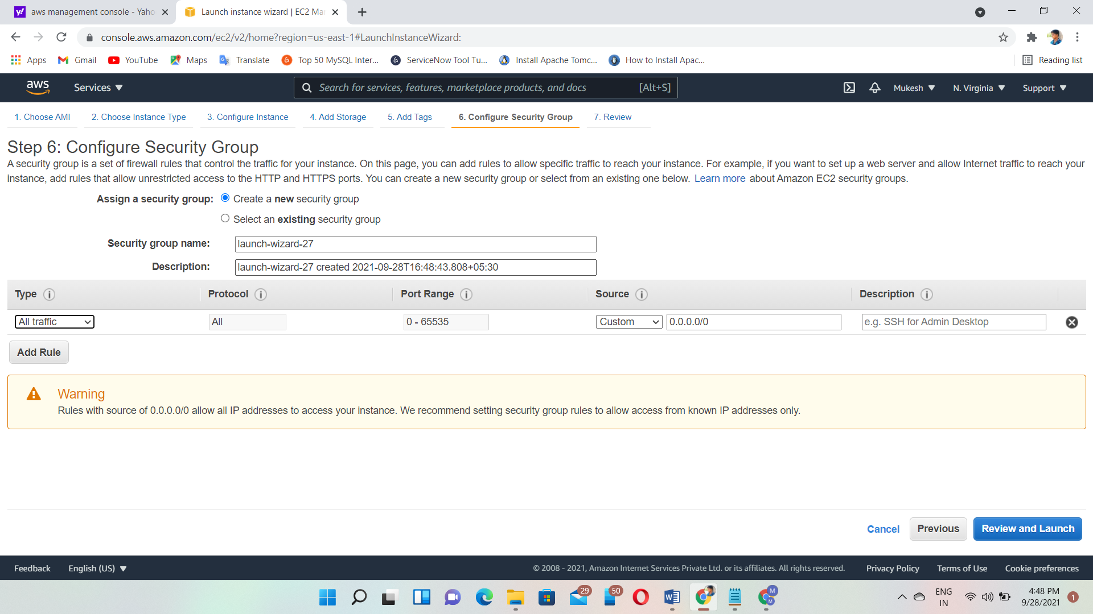

Public IP – 54.210.8.234

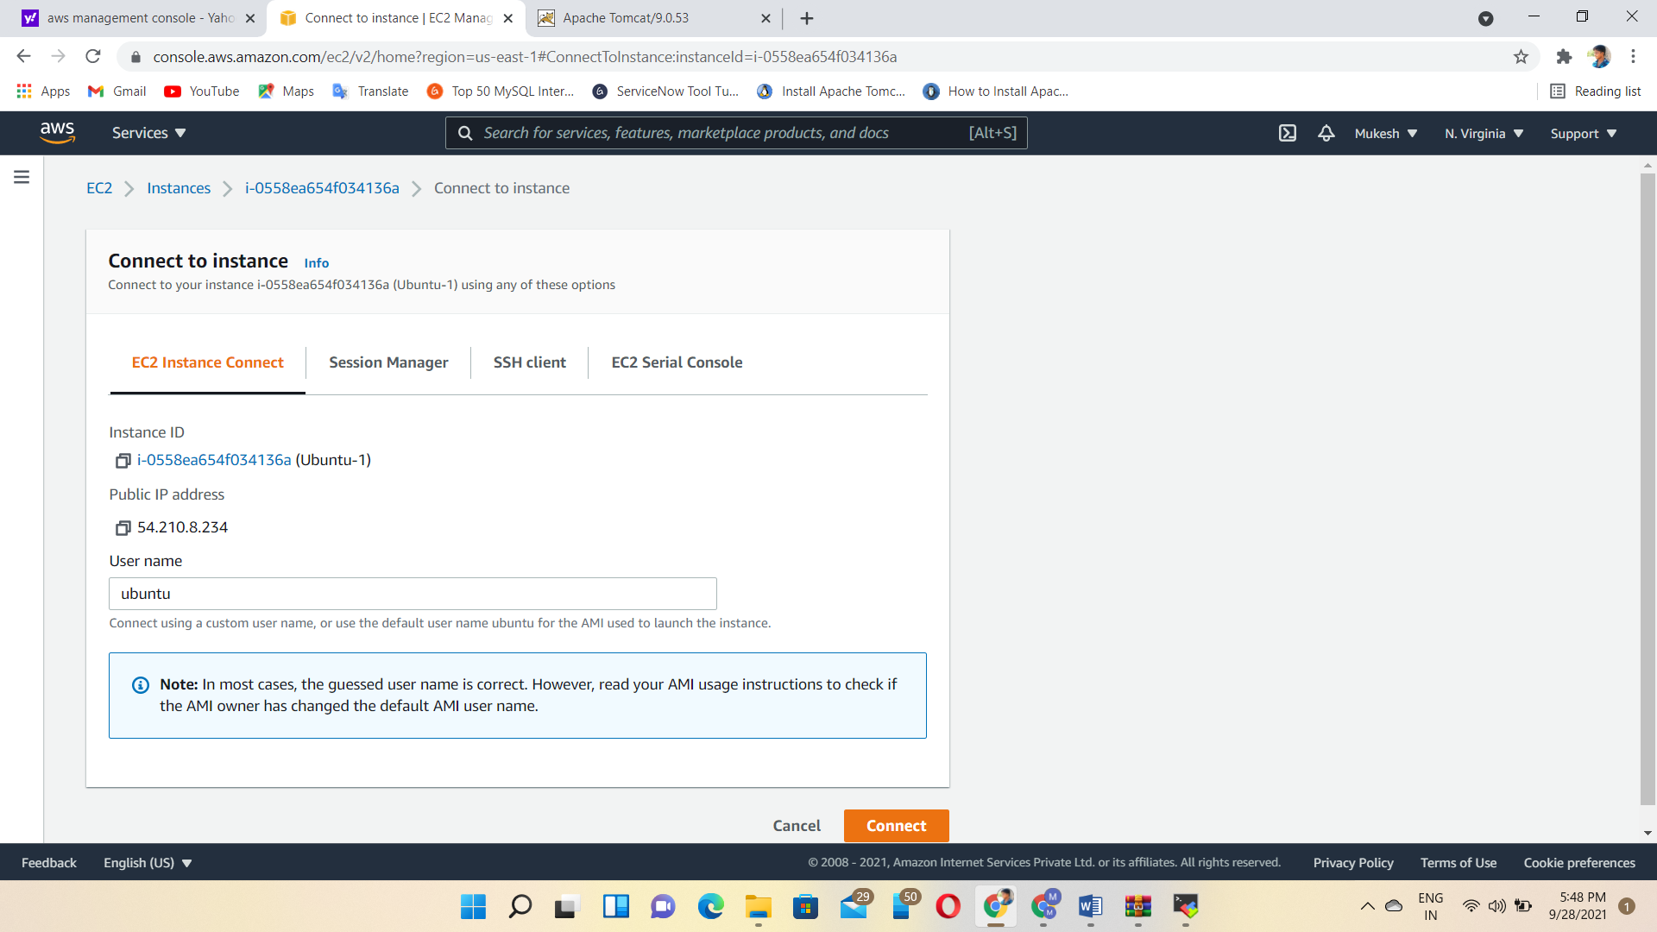

After Connect:

Command:

1🡪sudo su

2🡪apt update

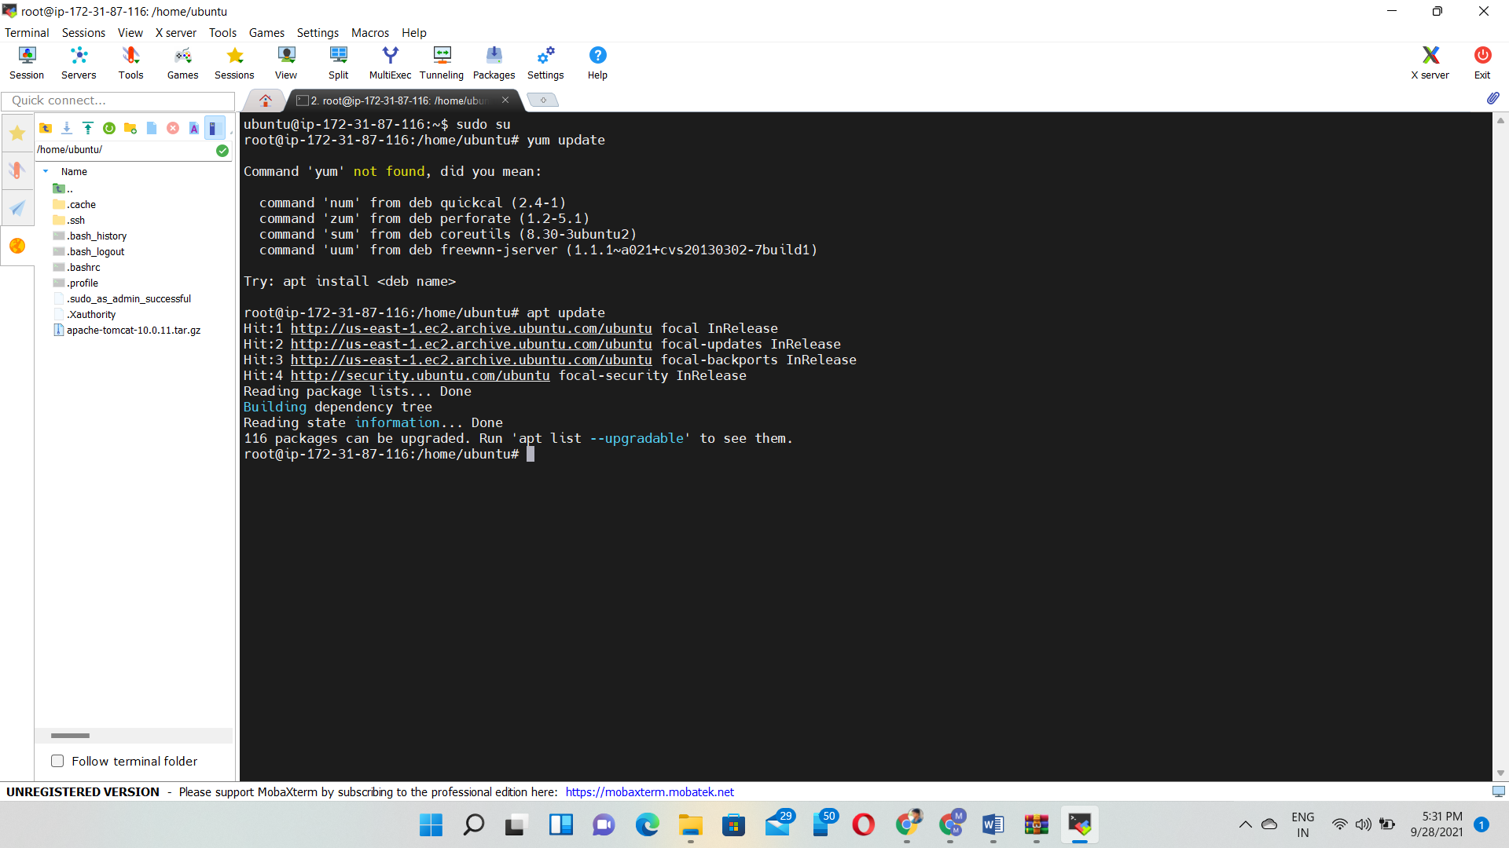

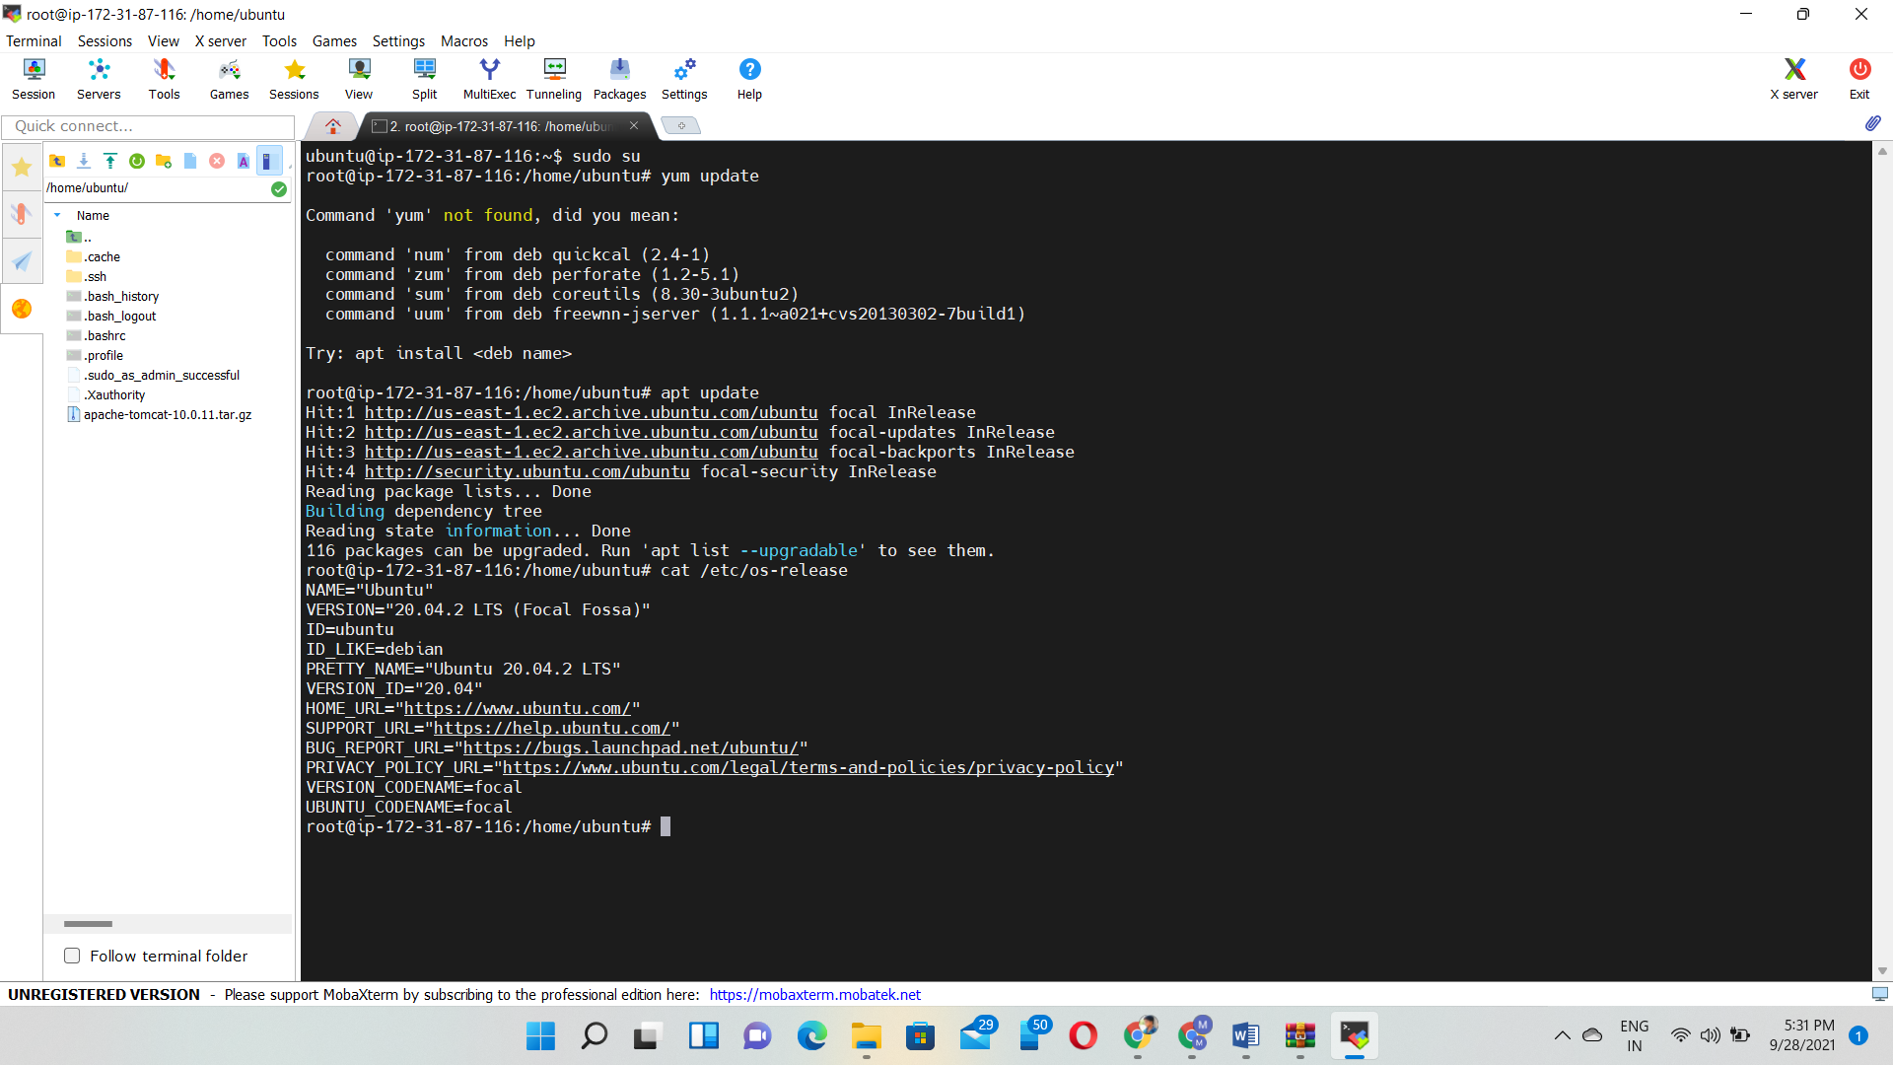

3🡪apt install default-jdk -y

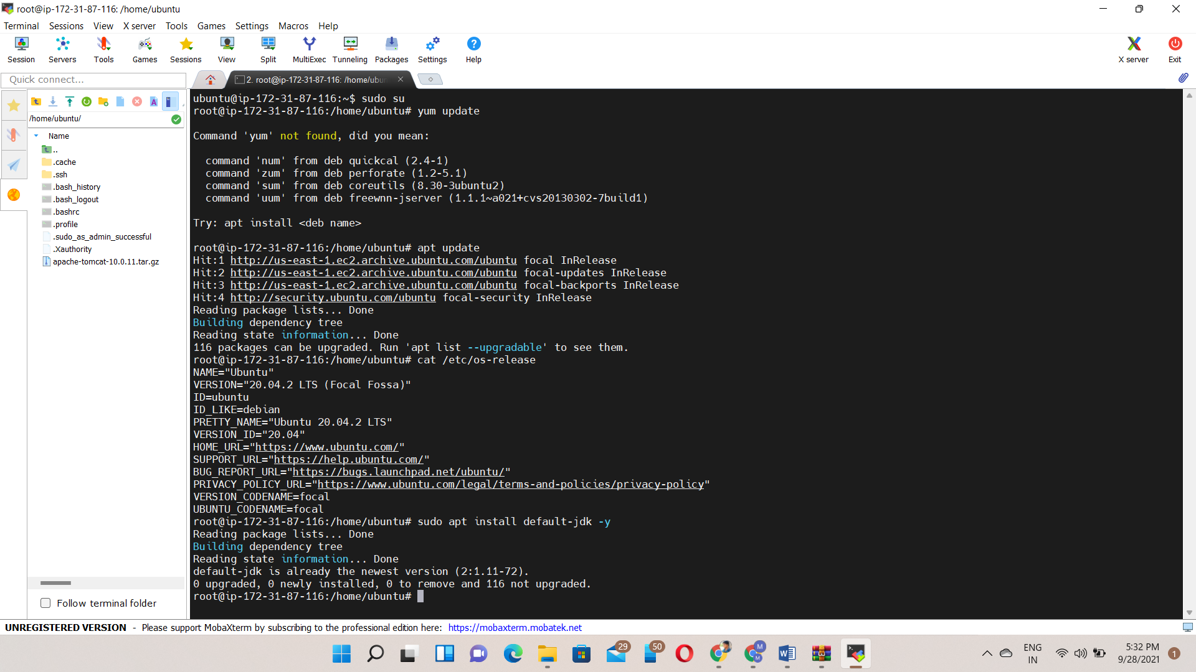

4🡪sudo useradd -m -d /opt/tomcat -U -s /bin/false tomcat

5🡪wget https://dlcdn.apache.org/tomcat/tomcat-9/v9.0.53/bin/apache-tomcat-9.0.53.tar.gz

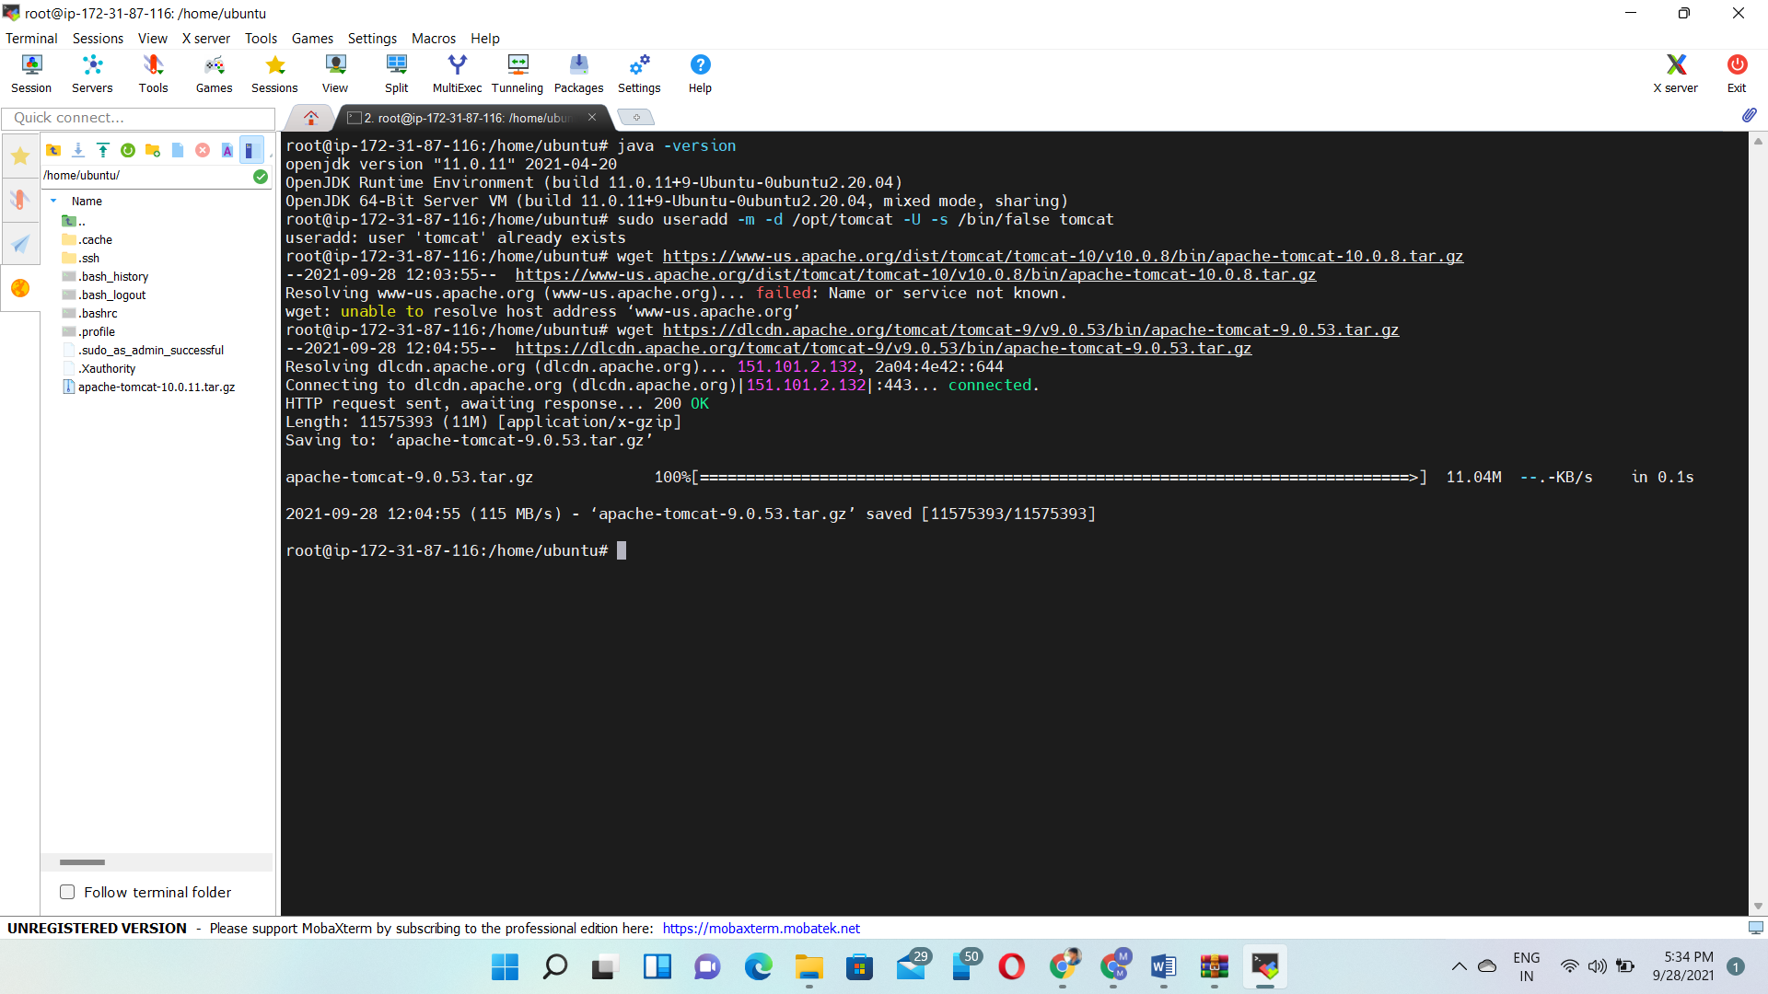

6🡪sudo tar xzvf apache-tomcat-9.0.53.tar.gz -C /opt/tomcat --strip-components=1

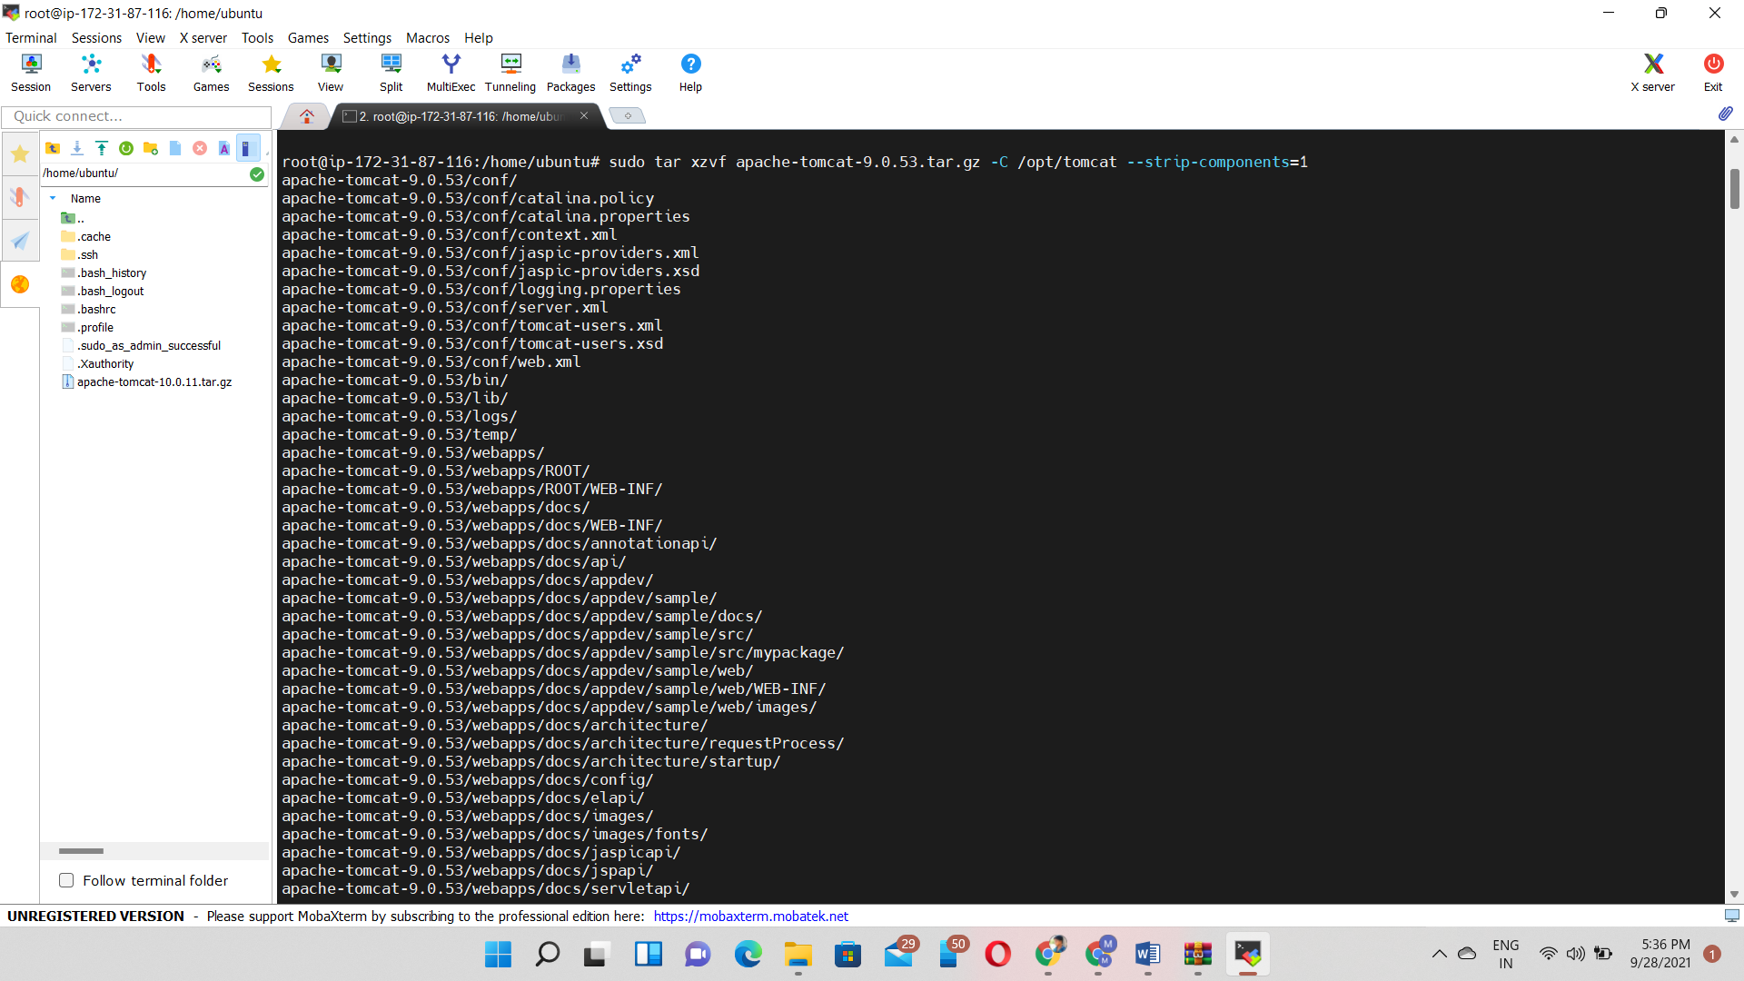

7🡪sudo chown -R tomcat:tomcat /opt/tomcat/

8🡪sudo chmod -R u+x /opt/tomcat/bin

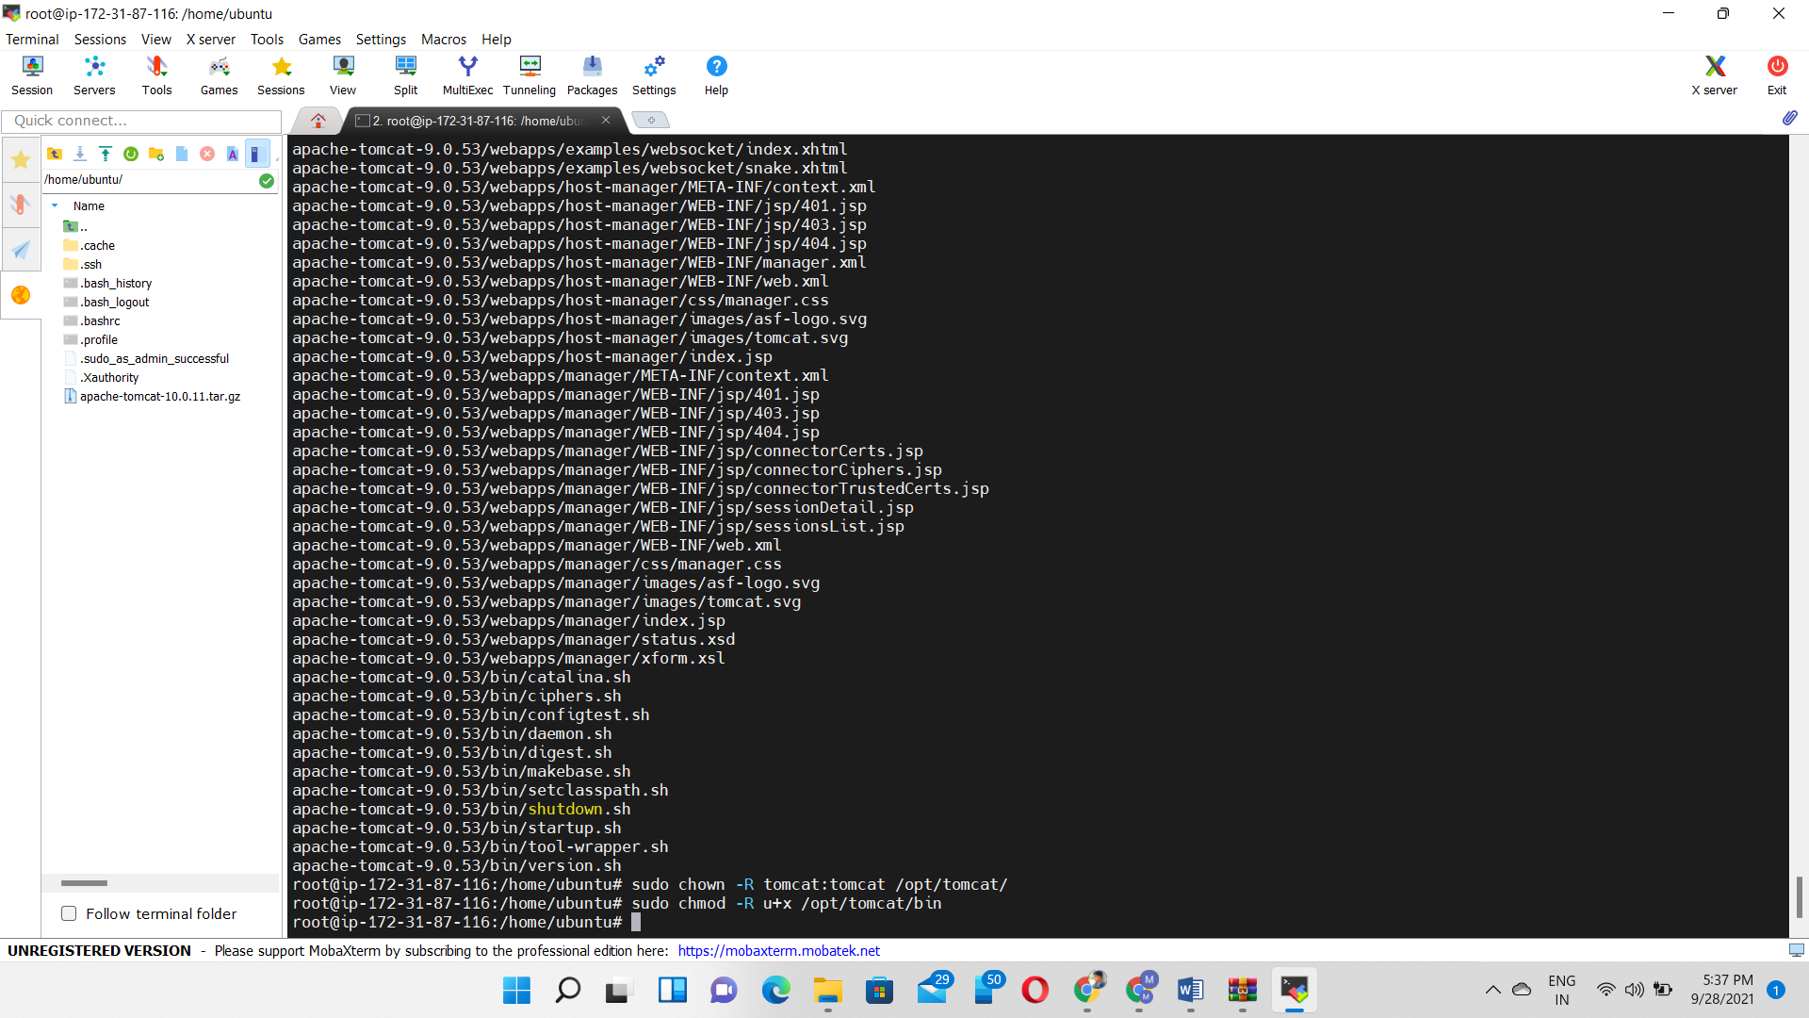

9🡪sudo nano /opt/tomcat/conf/tomcat-users.xml

10🡪sudo nano /etc/systemd/system/tomcat.service

[Unit]

Description=Tomcat

After=network.target

[Service]

Type=forking

User=tomcat

Group=tomcat

Environment="JAVA_HOME=/usr/lib/jvm/java-1.11.0-openjdk-amd64"

Environment="JAVA_OPTS=-Djava.security.egd=file:///dev/urandom"

Environment="CATALINA_BASE=/opt/tomcat"

Environment="CATALINA_HOME=/opt/tomcat"

Environment="CATALINA_PID=/opt/tomcat/temp/tomcat.pid"

Environment="CATALINA_OPTS=-Xms512M -Xmx1024M -server -XX:+UseParallelGC"

ExecStart=/opt/tomcat/bin/startup.sh

ExecStop=/opt/tomcat/bin/shutdown.sh

[Install]WantedBy=multi-user.target

11🡪systemctl daemon-reload

12🡪systemctl start tomcat.service

13🡪systemctl enable tomcat.service

14🡪systemctl status tomcat.service

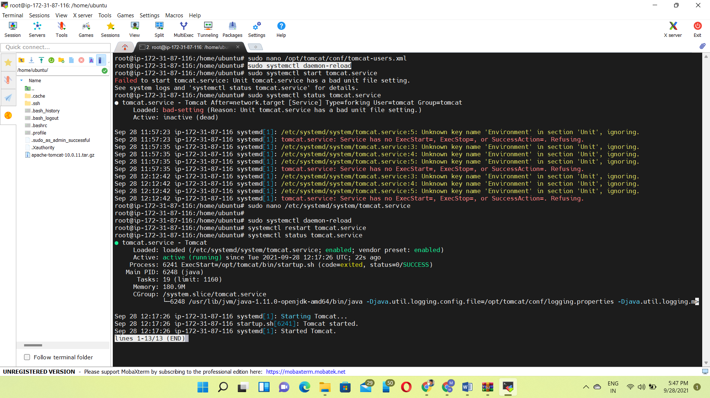

Output:

